WEEK 3
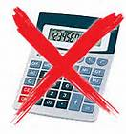
- Tanya recorded temperatures on a mountain over four days. Which list gives four temperatures arranged in order from lowest to highest?
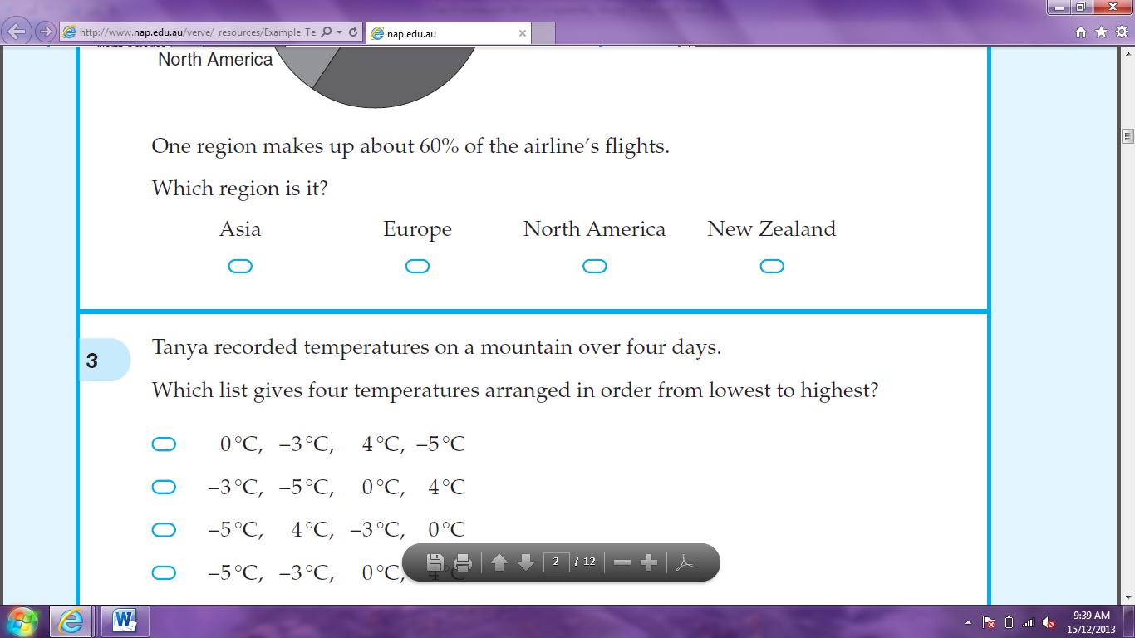
0°C, -3°C, 4°C, -5°C

-3°C, -5°C, 0°C, 4°C

-5°C, 4°C, -3°C, 0°C

-5°C, -3°C, 0°C, 4°C

- 25% of Rochelle’s income is spent on rent. If Rochelle earns $1280 per week, how much is her weekly rent?

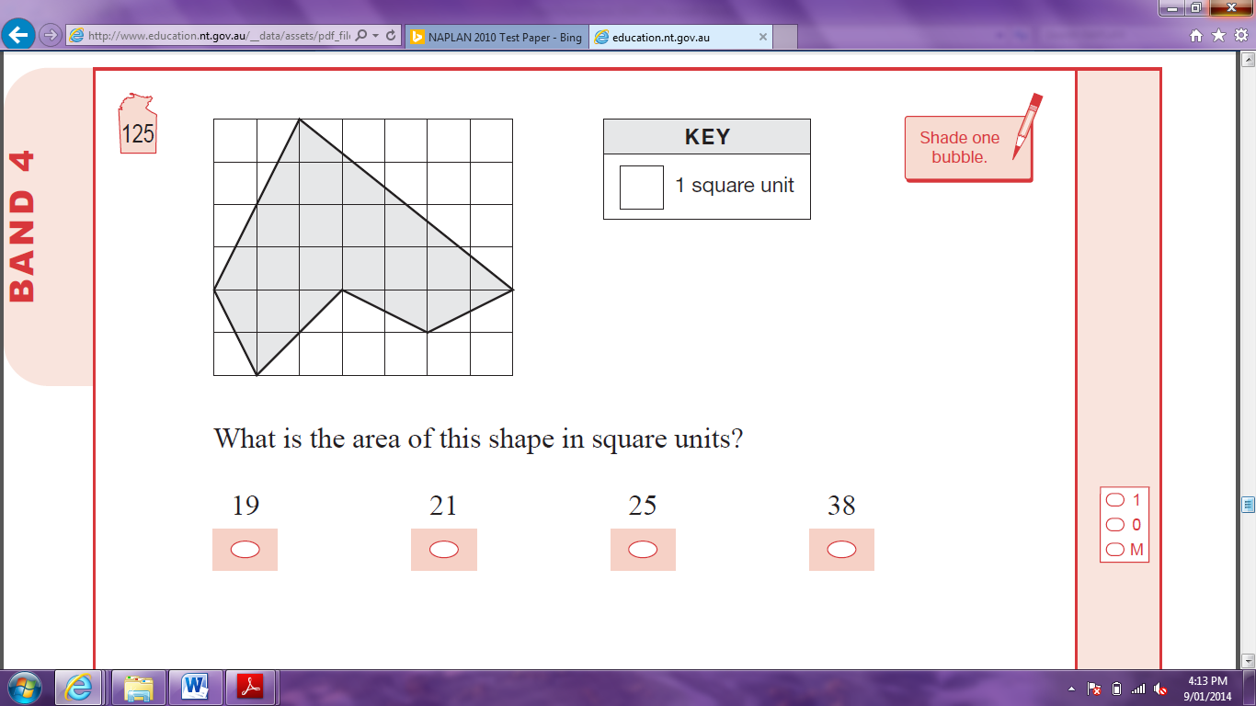
- What is the area of this shape in square units?

- When it is 11 am in Perth, it is 3pm in Auckland on the same day. At 9 pm in Perth, Sophie phoned a friend in Auckland. What was the time in Auckland when Sophie phoned?

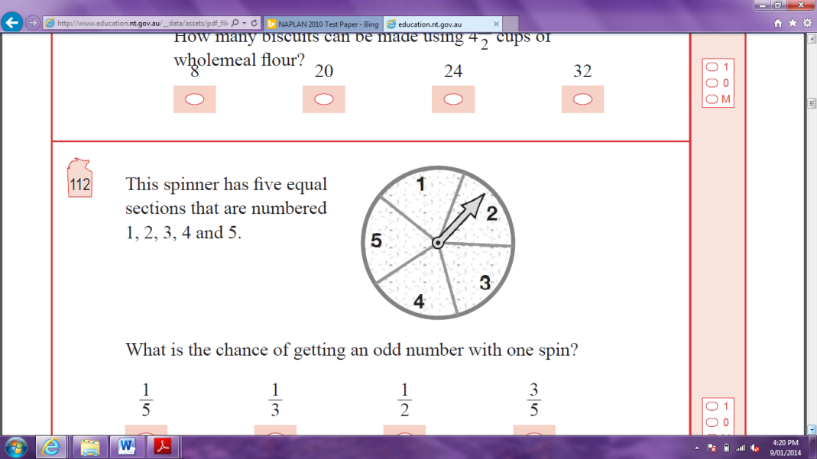
- This spinner has five equal sections that are numbered 1, 2, 3, 4 and 5. What is the chance, as a fraction, of getting an odd number with one spin?

- What is the next number in the pattern: 2, 2.6, 3.2, 3.8, 4.4, ?

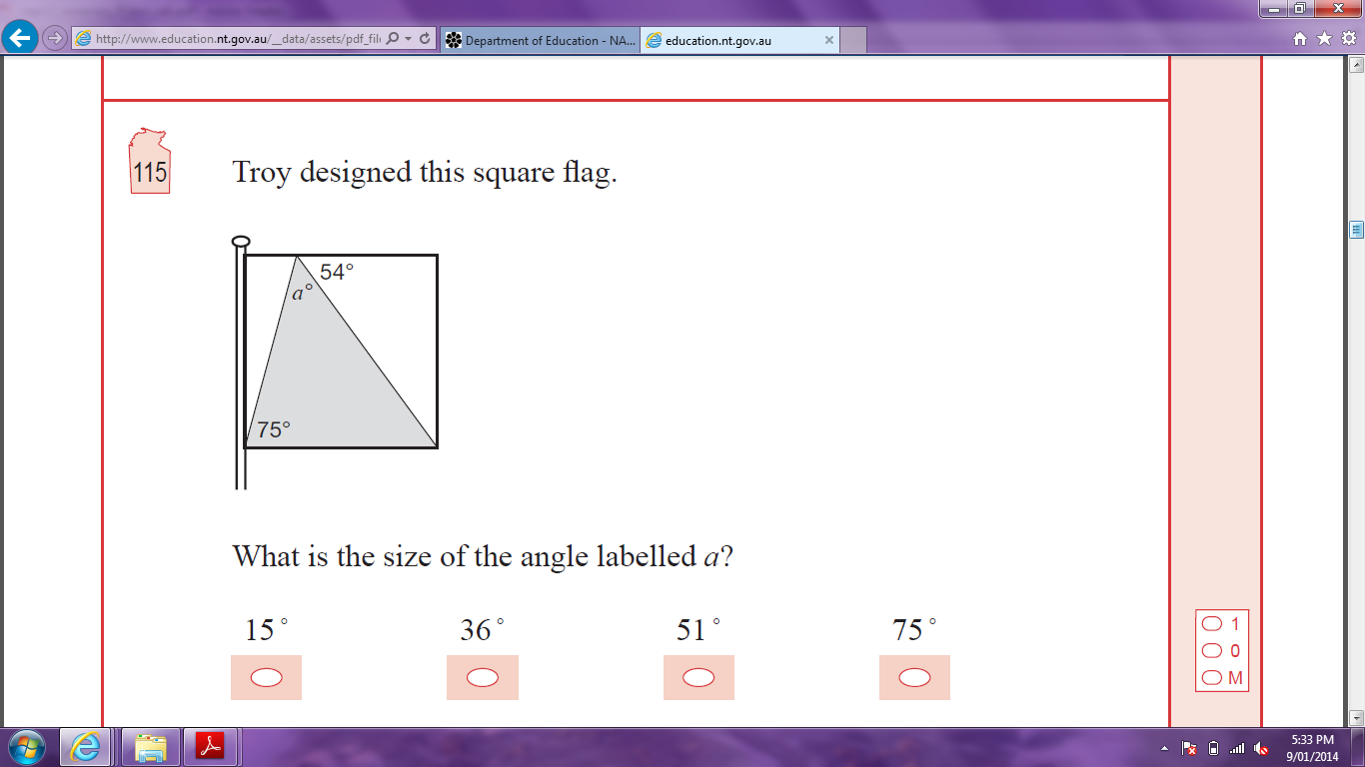
- Troy designed this square flag. What is the size of the angle labelled a?

- What fraction has the same value as ?





- Which value of x does not satisfy the inequality 2x – 3 ≤ 8?




x = -4 x = 0 x = x = 7
85 cm2
- The area of this rectangle is 85 cm². What is the length of the rectangle?


- Here is a set of five scores: 4, 2, 6, 4, 4. Which is equal to 4?

Mode only

Mode and range only

Mode, mean and range only
Mode, mean, median and range

- What is the value of x?

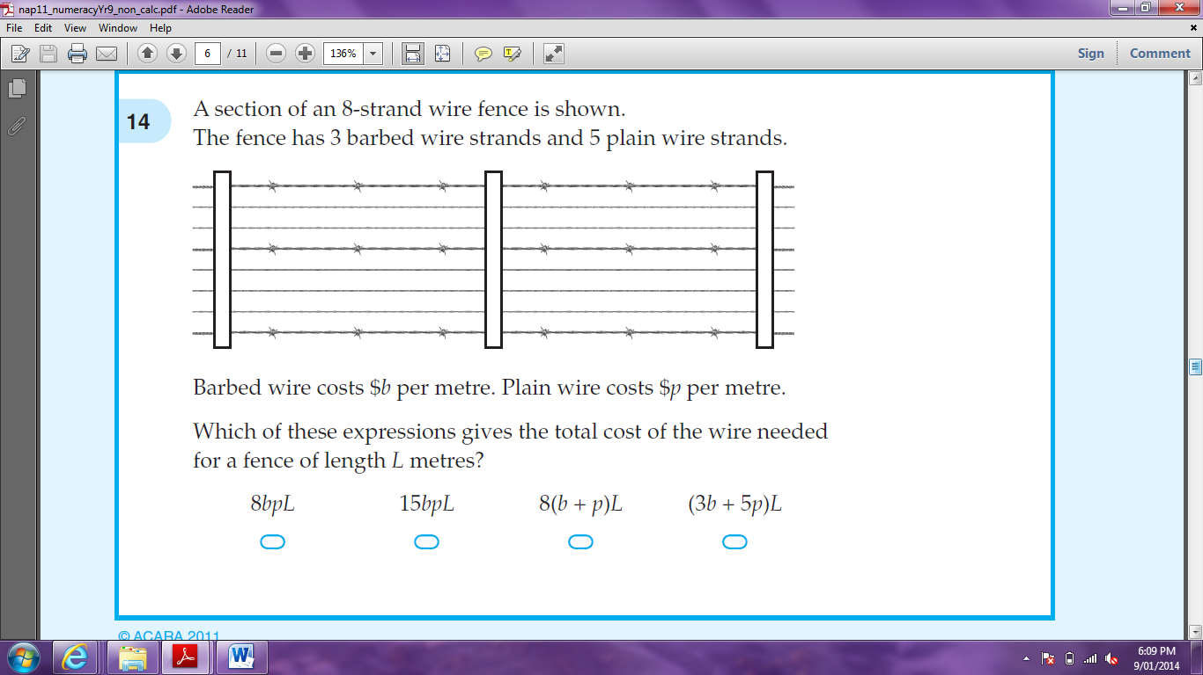
- A section of an 8-strand wire fence is shown. The fence has 3 barbed wire strands and 5 plain wire strands.

Barbed wire costs $b per metre. Plain wire costs $p per metre. Which of these expressions gives the total cost of the wire needed for a fence of length L metres?




8bpL 15bpL 8(b + p)L (3b + 5p)L

- Jorja ate 40% of a pie on Saturday and ate 40% of the remaining pie on Sunday. How much of the pie remained on Monday?

- When 1 mm of rain falls on 1 m² of the surface of a pond, 1 litre of water is collected. What surface area of the pond is needed to collect 10 000 litres from a rainfall of 20 mm?


- Sam buys 16 tickets to a concert. The tickets cost $27 each. Which of these could Sam use to calculate the total cost?

(27 x 10) + 6

(27 x 10) x 6

(20 x 10) + (7 x 6)
(27 x 10) + (27 x 6)

